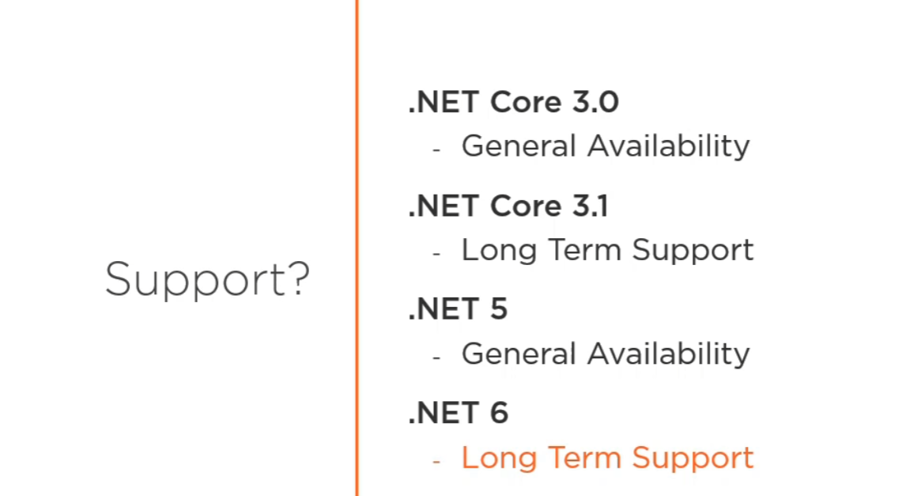

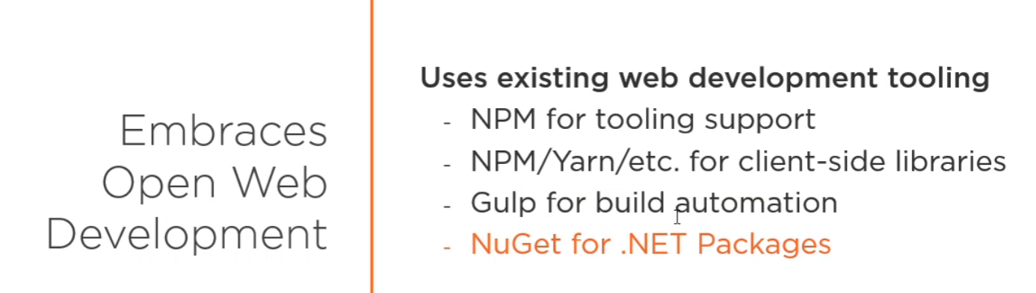

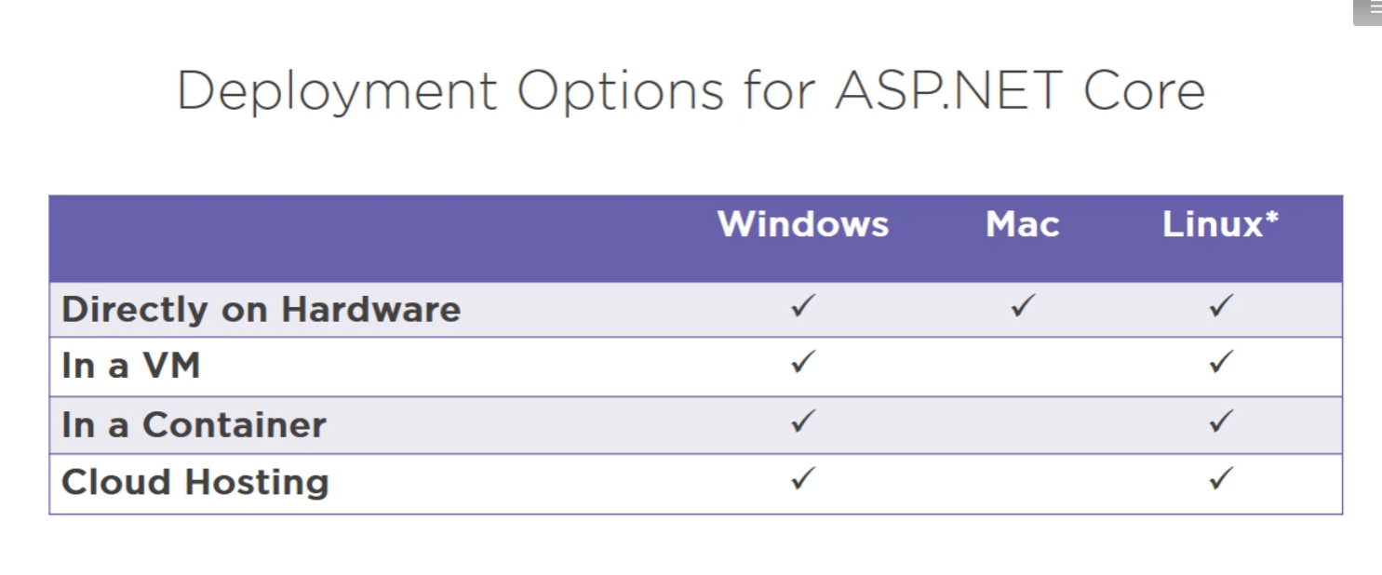

<https://www.backblaze.com/blog/vm-vs-containers/>

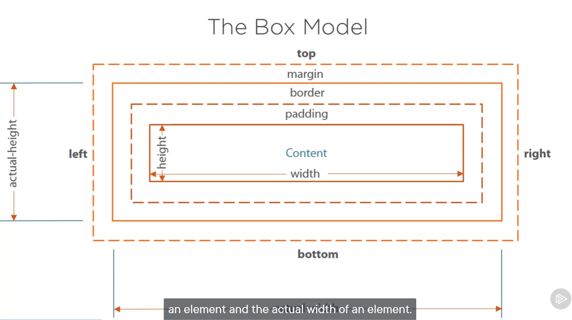

display : Inline-block; only border for content

float : left; take space on left but leave right space for other div element

Add js library suing add new in vs 2019

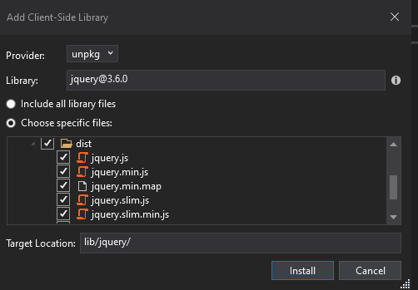

<https://madasamy.medium.com/javascript-brief-history-and-ecmascript-es6-es7-es8-features-673973394df4>

Jquery will detect different browser by itself. Deal with global scope.

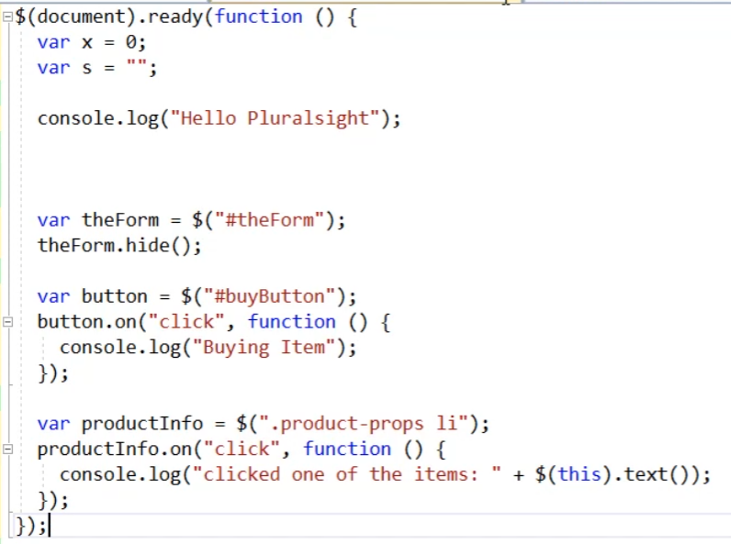

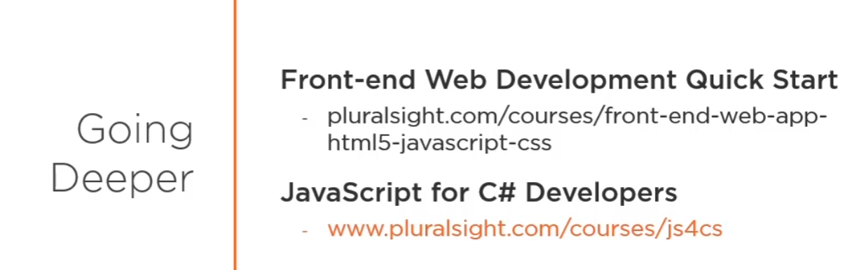

public class ManageController : Controller (base class)

[HttpGet]

public async Task<IActionResult> MyAccount()

{

var user = await _userManager.GetUserAsync(User);

if (user == null)

{

throw new ApplicationException($"Unable to load user with ID '{_userManager.GetUserId(User)}'.");

}

var model = new IndexViewModel

{

Username = user.UserName,

Email = user.Email,

PhoneNumber = user.PhoneNumber,

IsEmailConfirmed = user.EmailConfirmed,

StatusMessage = StatusMessage

};

return View(model);

}

View: has naming convention to Look for a Views->Manager->MyAccount.cshtml

View(model) : return the model data to match with page element

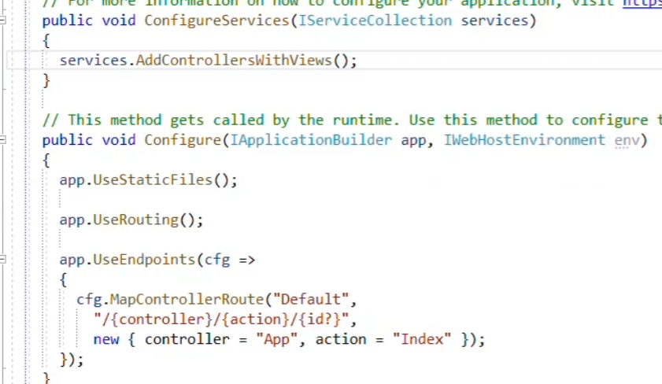

* Added controller view service
* Config default routing : follow up /controller action and id pattern but id could be optional
* Also default controller is App and action is index.cstml
* If(env.IsDevelopment) => match with ASPNETCORE_ENVIRONEMENT settingD

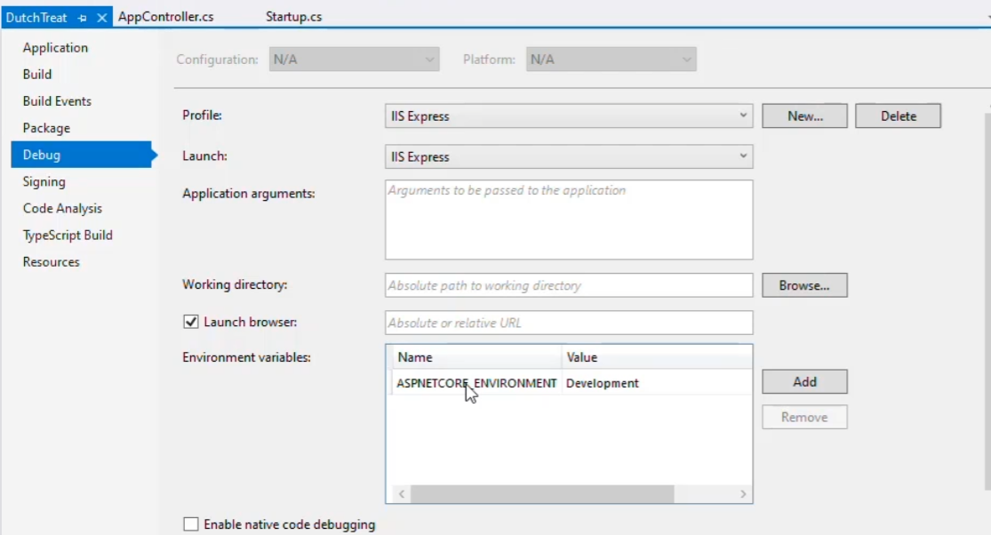

* App.UseDevelopmentExceptionPage() to handle exception

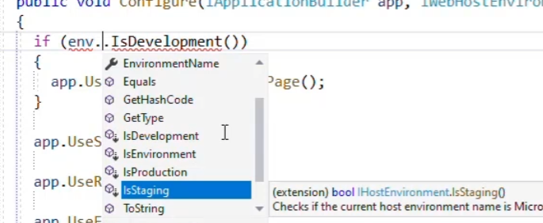

**Chapter 5 Using ASP.NETMVC**

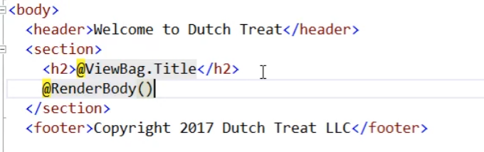

<https://exceptionnotfound.net/asp-net-mvc-demystified-layout-viewstart-renderbody-and-rendersection/#:~:text=RenderBody()%20is%20called%20to,container%20body%2Dcontent%22%3E%20>.

Added CSS and JS to this page Under Views folder

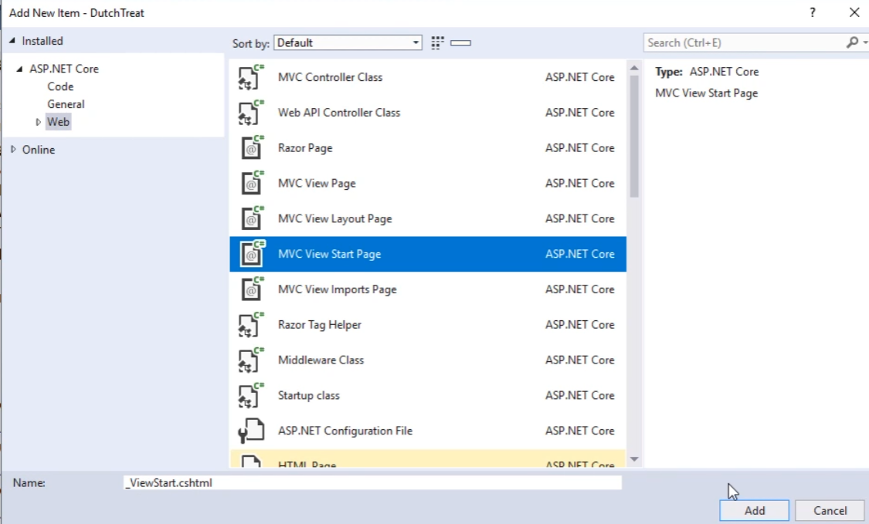

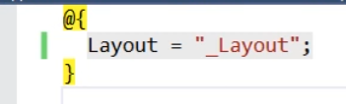

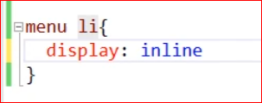

Added tag helper (help hard coded url like app/contact etc) Under Views folder

Add common name spaces for every page

@using Microsoft.eShopWeb.Web

@using Microsoft.eShopWeb.Web.ViewModels

@using Microsoft.eShopWeb.Web.ViewModels.Account

@using Microsoft.eShopWeb.Web.ViewModels.Manage

@using Microsoft.eShopWeb.Web.Pages

@using Microsoft.AspNetCore.Identity

@using Microsoft.eShopWeb.Infrastructure.Identity

@namespace Microsoft.eShopWeb.Web.Pages

@addTagHelper *, Microsoft.AspNetCore.Mvc.TagHelpers 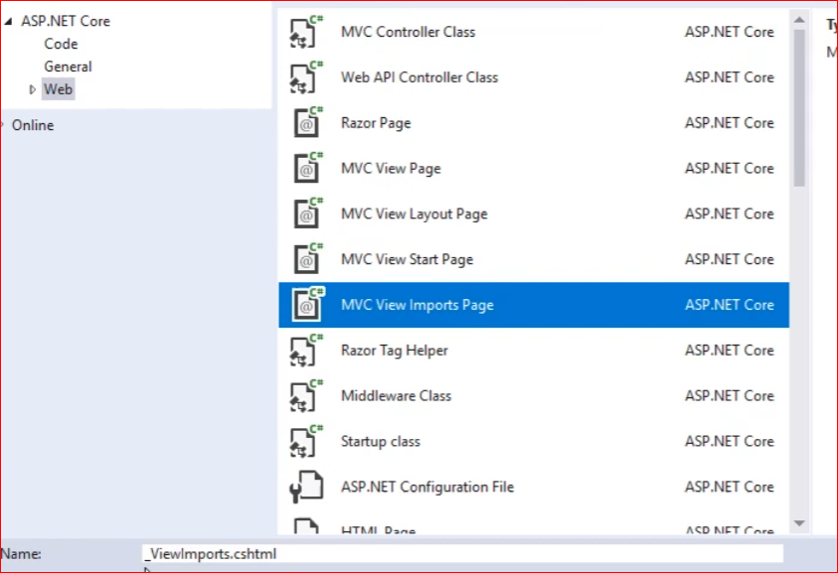

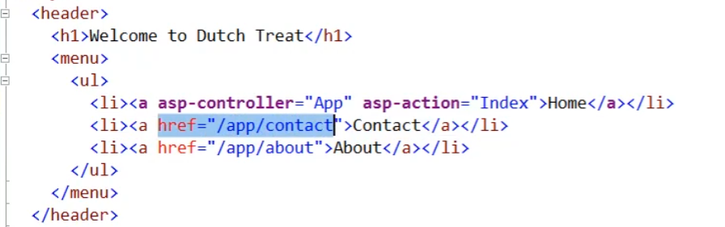

Make link is not fragile

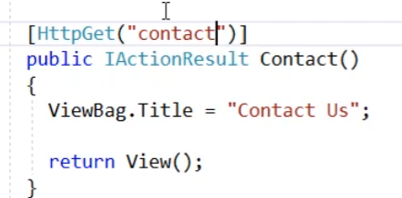

Error page for Production

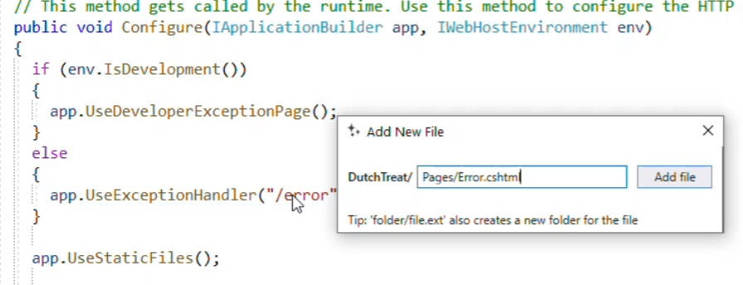

@page into Error.cshtml

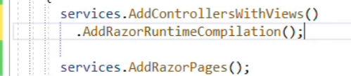

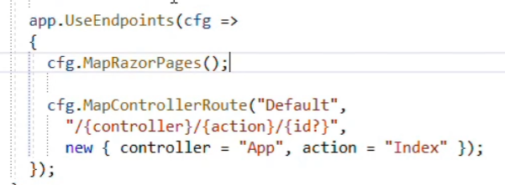

<https://docs.microsoft.com/en-us/aspnet/core/mvc/views/view-compilation?view=aspnetcore-5.0&tabs=visual-studio>

Enable razor page runtime compilation is very important for development

Check form post

Giving name of every fields.

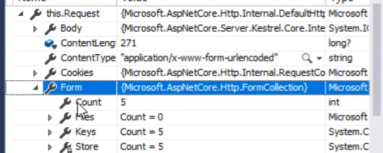

**Model binding**

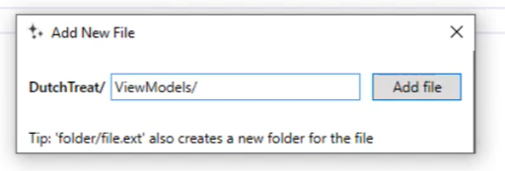

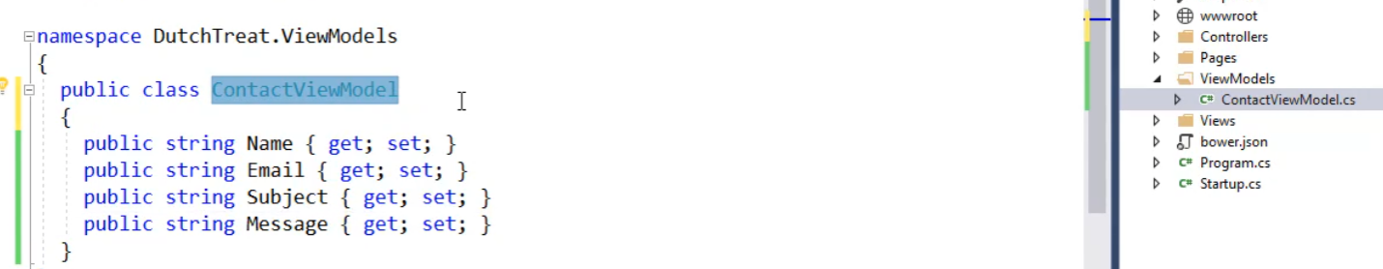

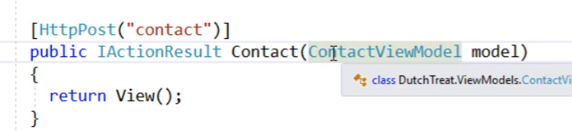

Better

@model ContaatViewModel and add it to _viewImports.cshtml

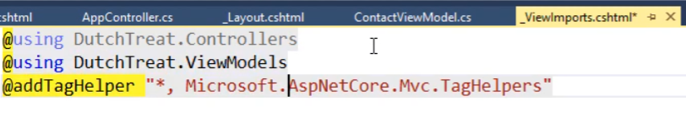

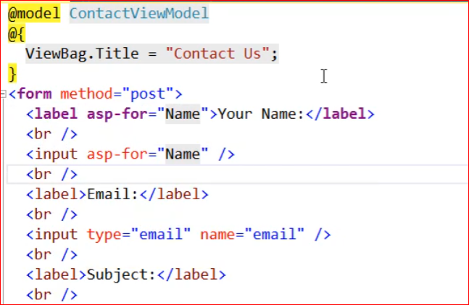

Validation using data annotation

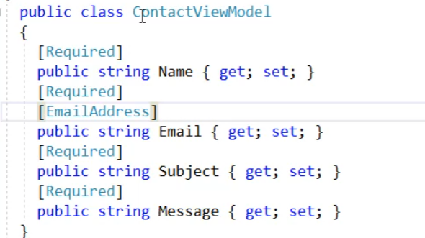

Asp-validation-summery

[error =”too long”] on data annotation

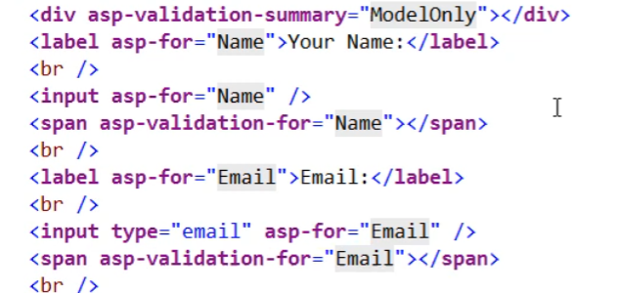

Add Jquery-validaton from client side library

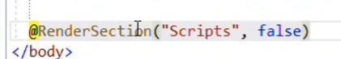

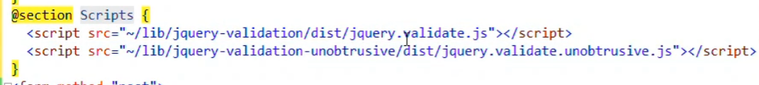

Losing cursor error show up right away

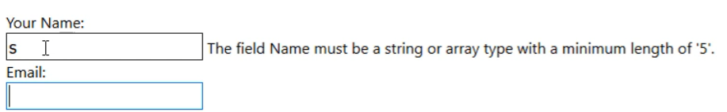

Add service

Singleton: for share state and expensive constructed

Scope : database object for every request

Transient : died after every instance or request

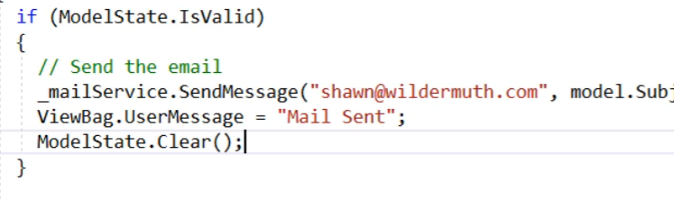

**Chapter 6 Using Bootstrap**

* Added client side library
* Added bootstrap css(top) and js (bottom)to layout file

Add container and give back ground color to test RESPONSIVE version

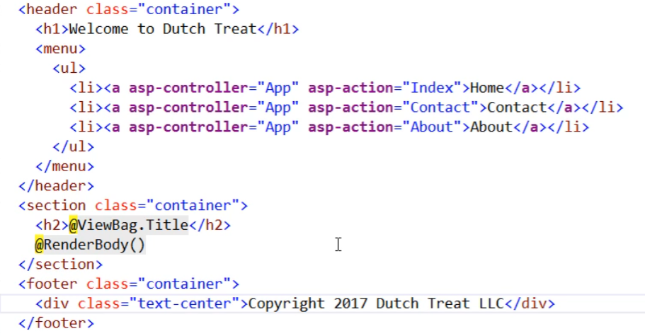

NavBar (md means middle size screen using horizontal)

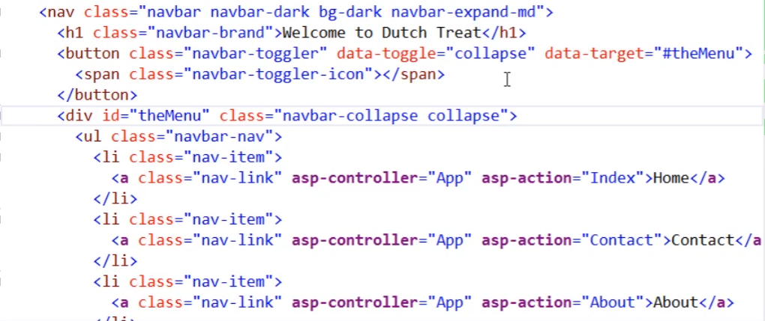

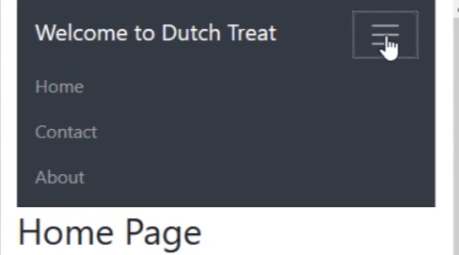

The Bootstrap grid system

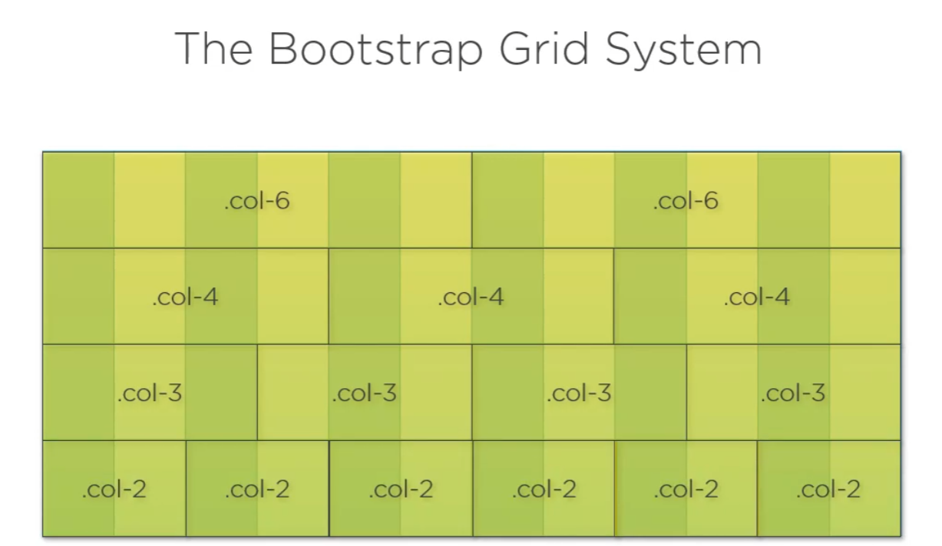

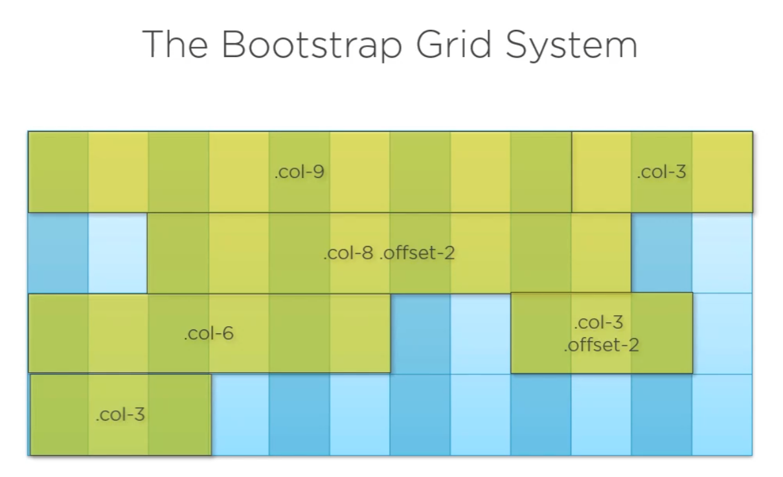

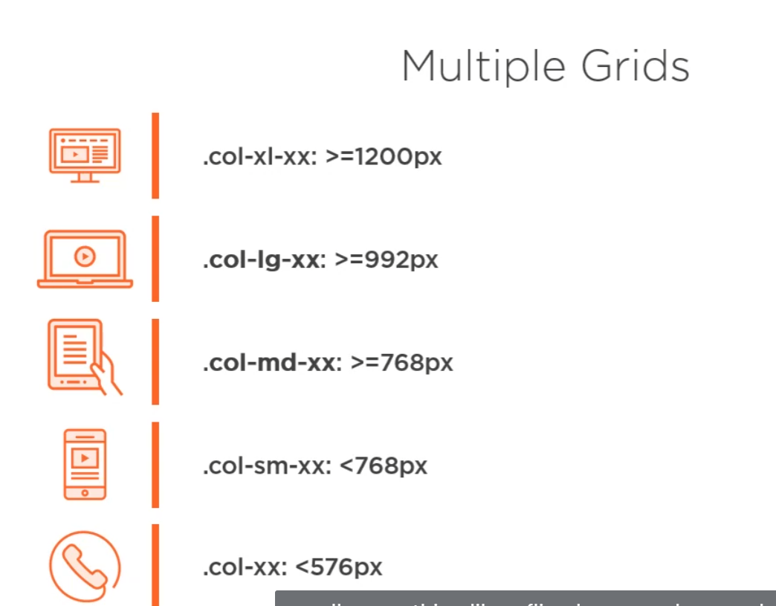

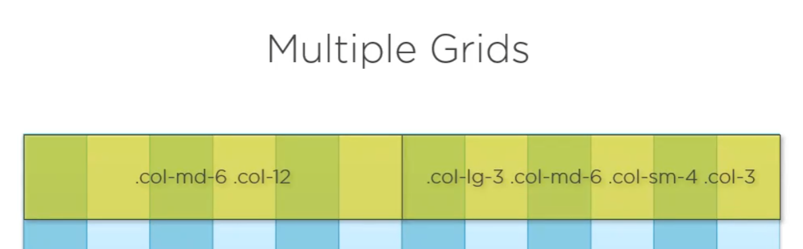

<div calss=”row”>

<div class=”col-md-6”></div>

<div class=”col-md-6”> </div>

</div

Card is just a container

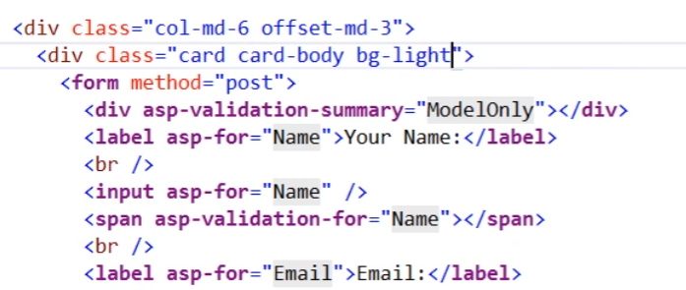

Bootstrap for the form

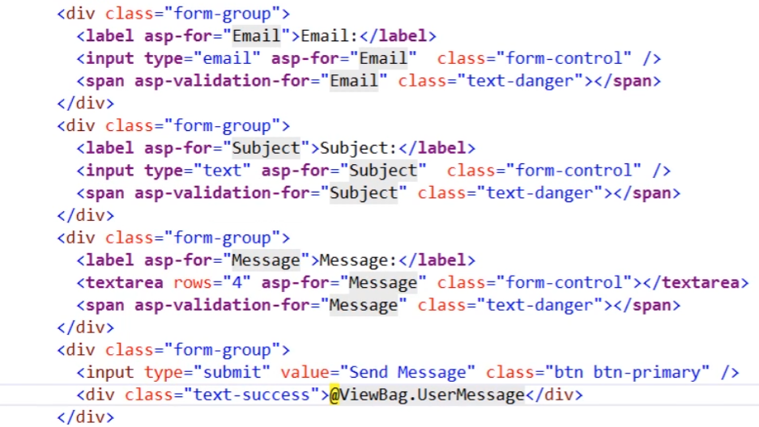

**Use font awesome**

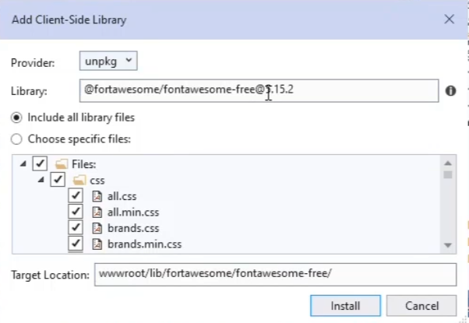

Need css and webfount component only

Better icon





Fas is solid

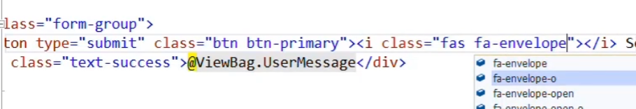

**Chapter 7 Using Entity framework core**

Create seed data

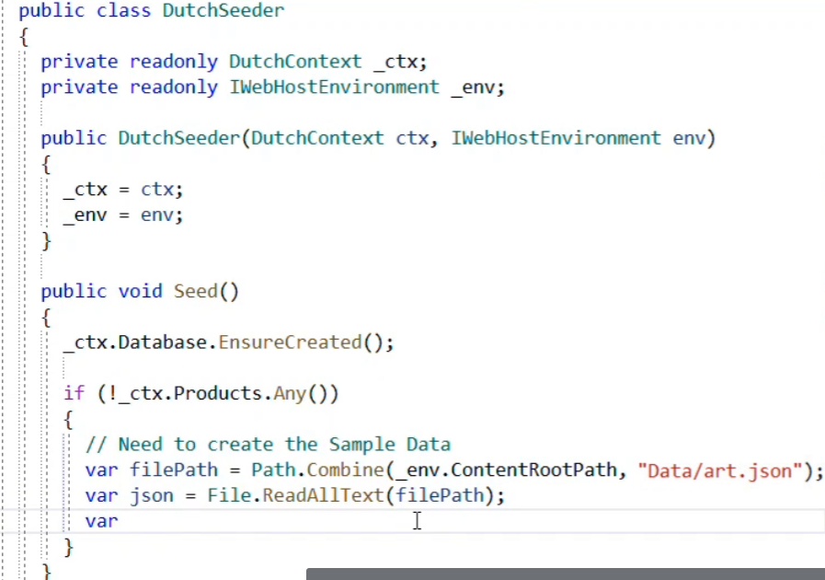

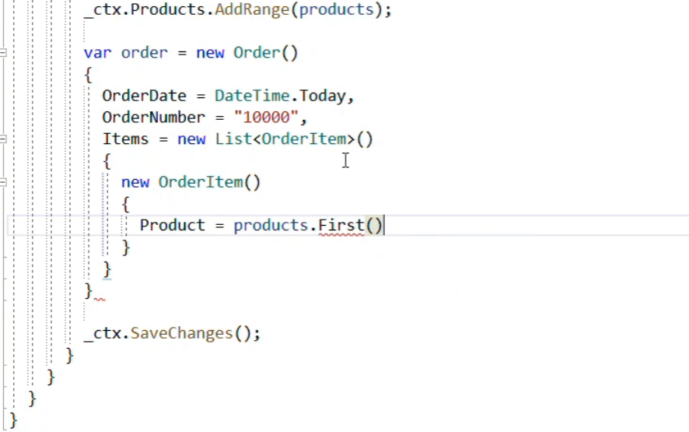

Call seeds function in program.cs

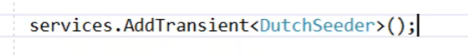

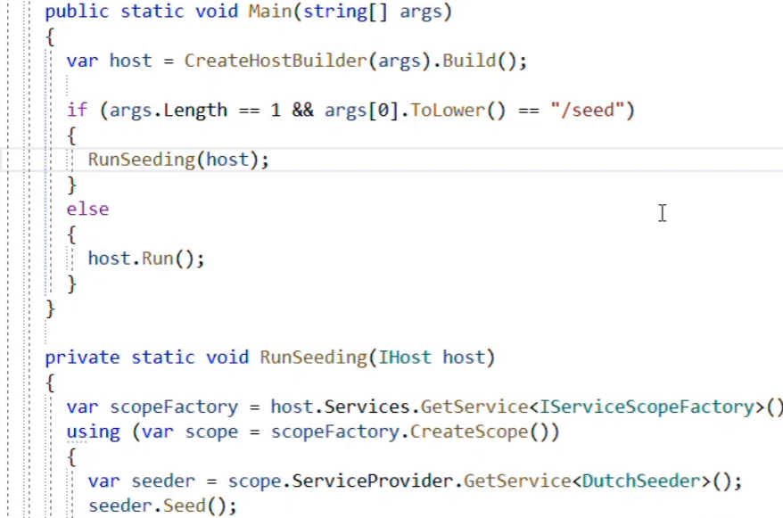

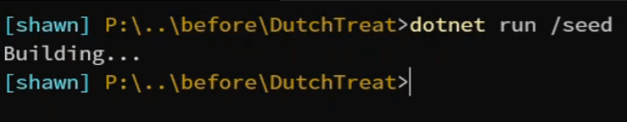

**Repository pattern**

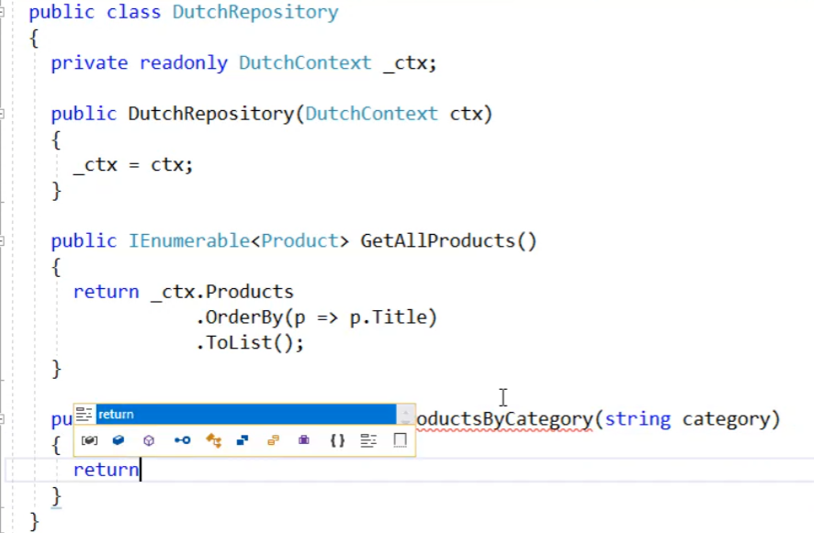

**Logging**

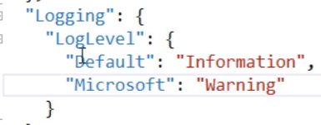

**Chapter 7 Creating API with ASP.Net MVC**

<https://github.com/dotnet/AspNetCore.Docs/tree/main/aspnetcore/web-api/index/samples/3.x>

[ApiController]

[Route("api/[controller]")]

public class ConsumesController : ControllerBase

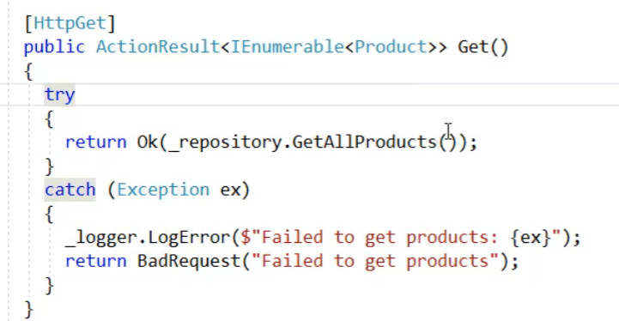

**In case you like to get return from all different data format.**

[**https://docs.microsoft.com/en-us/aspnet/core/web-api/?view=aspnetcore-5.0**](https://docs.microsoft.com/en-us/aspnet/core/web-api/?view=aspnetcore-5.0)

Include to have data collecction

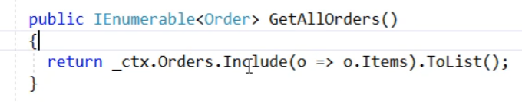

Solve recursive reference issue

Order item has order

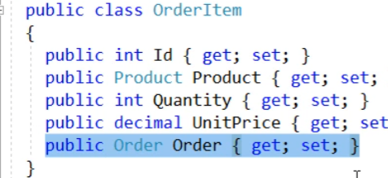

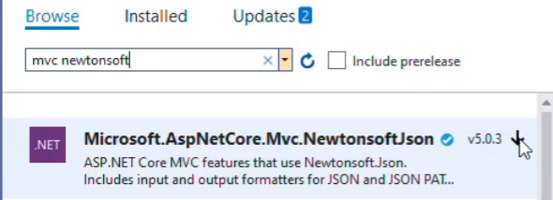

services.AddMvc().AddNewtonsoftJson(options => options.SerializerSettings.ReferenceLoopHandling = ReferenceLoopHandling.Ignore);

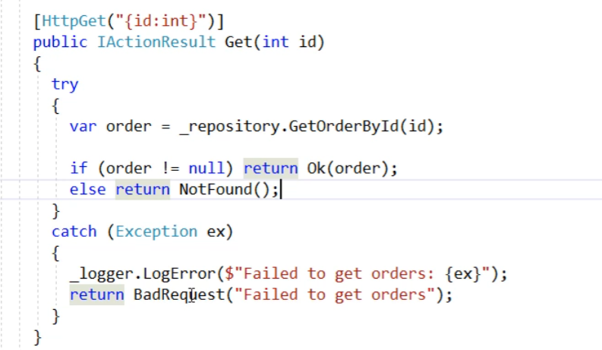

Post; why not put SaveAll to repository of SaveChanges?

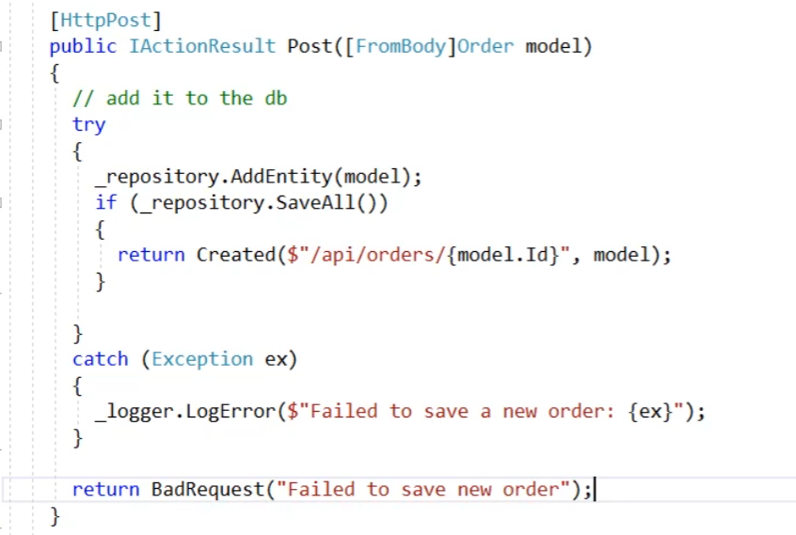

**No-tracking queries**

No tracking queries are useful when the results are used in a read-only scenario.

Validation of view model in API